Island_Orchestration_Solution_Documentation
Written by: Yuval Quina
I started this CTF by performing a Nmap tcp open ports and services scan over the target machine:
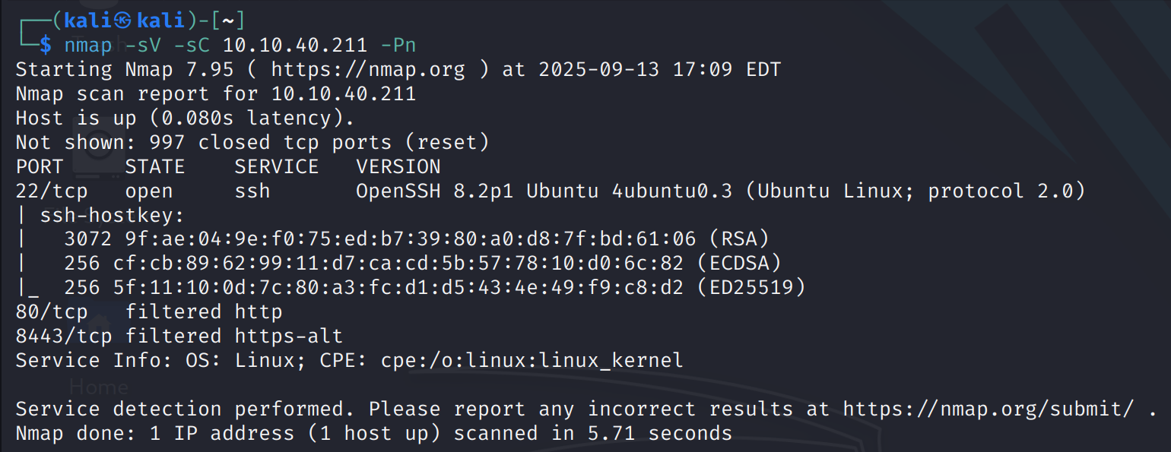
I discovered that the target has filtered 80 and 8443 ports which are used for websites, which means that there is a firewall that blocks me from entering the website from outer device. This led me to find an exploit for OpenSSH 8.2p1 in order to get a shell over the target. I found this exploit on github:
https://github.com/LucasPDiniz/CVE-2023-38408
After setting the parameters and running the exploit’s code it

